|  |  |
| --- | --- |
| ENEMLOS NEWSLETTER Issue 1/2023 | |
| PMT meeting with nonacademic partners from Montenegro | |  | | --- | | Porto | | January, February and March 2023 |   sue |
| PMT meating with non academic partners: The meeting discussed the implementation of legal clinics during the winter semester of 2022/23 school year. |
| In this issue: | |
|  |  |
|  | |

TRAINING OF LAW STUDENT by 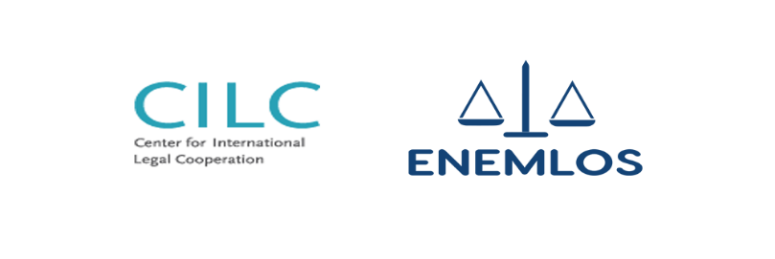 Prof. Dr. Biljana Đuričin, Assoc. Dr. Nikola Dožić and Assoc. dr Velibor Korać

*PMT MEETING MARCH, 2023*

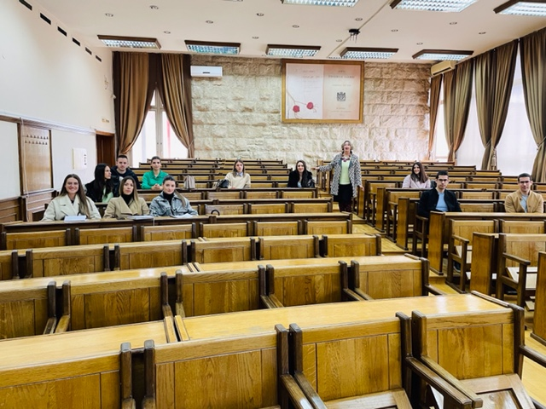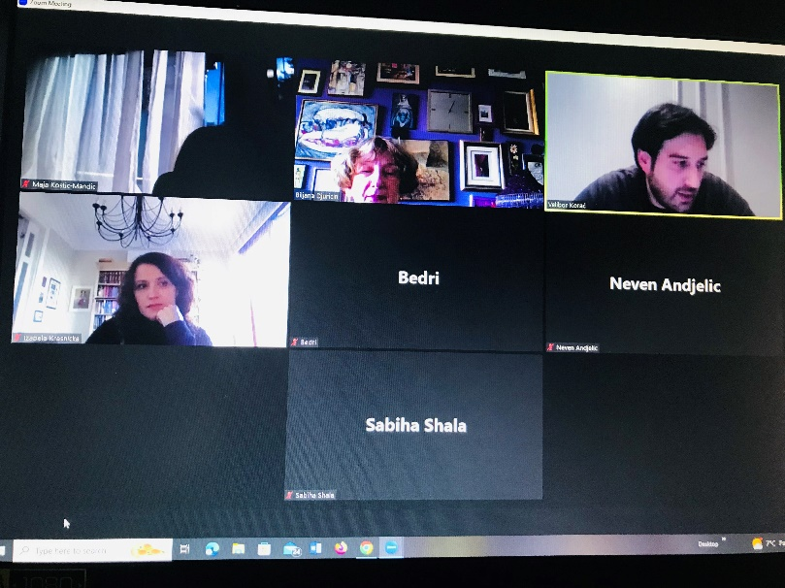ENEMLOS Editorial Board met on February 9, 2023. Meeting was organized online through ZOOM platform. Papers for the new book of best clinical legal education practice were accepted at the meeting.